|  | **MEENAKSHI SUNDARARAJAN ENGINEERING COLLEGE**  **Kodambakkam, Chennai-600024**  **(An Autonomous Institution)** |  |
| --- | --- | --- |

**NM1042 – MERN STACK POWERED BY MONGODB**

**DEPARTMENT OF INFORMATION TECHNOLOGY**

**PROJECT TITLE: Grocery Webapp**

| **TEAM ID:** | **NM2024TMID11879** |
| --- | --- |
| **FACULTY MENTOR:** | **ASWINI G** |

**Project submitted by,**

| **NAAN MUDHALVAN ID** | **NAME** | **REGISTER NUMBER** |
| --- | --- | --- |
| 1257ECBDAD3650FB6AE46B2EF2109A91 | *JITHENDHARAN S* | *311521205025* |
| 94E857AA1FA1231B3ED4D0B93D629390 | *HEMA JEYANTH S* | *311521205021* |
| E0AB3274ACE57BB984744748D1B368F5 | *YOGESHWARAN N* | *311521205062* |
| 9F1799F7FDF9FF78D1E45FBCFF8ABF67 | *JEEVANATHAN B* | *311521205301* |

**Grocery Webapp**

**CATEGORY: FULL STACK DEVELOPMENT – MERN**

ABSTRACT

* Our basic Grocery-web app! Our App is designed to provide a seamless online shopping experience for customers, making it convenient for them to explore and purchase a wide range of products. Whether you are a tech enthusiast, a fashionista, or a homemaker looking for everyday essentials, our app has something for everyone.
* With user-friendly navigation and intuitive design, our grocery-webapp app allows customers to browse through various categories, view product details, add items to their cart, and securely complete the checkout process. We prioritize user satisfaction and aim to provide a smooth and hassle-free shopping experience.
* For sellers and administrators, our app offers robust backend functionalities. Sellers can easily manage their product listings, inventory, and orders, while administrators can efficiently handle customer inquiries, process payments, and monitor overall app performance.
* With a focus on security and privacy, our grocery-webapp app ensures that customer data is protected, transactions are secure, and personal information remains confidential. We strive to build trust with our customers and provide a safe platform for online shopping.
* We are excited to have you on board and look forward to providing you with a delightful shopping experience. Happy shopping with our Grocery-webapp!

**TABLE OF CONTENTS**

| **NO** | **TITLE** |
| --- | --- |
| **1** | Project description |
| **2** | Problem scenario |
| **3** | Requirements |
| **4** | Architecture design |
| **5** | Application flow |
| **6** | Features and functionalities |
| **7** | Database design |
| **8** | Implementation |
| **9** | Testing and deployment |
| **10** | Output screenshots |
| **11** | Challenges and solutions |
| **12** | Future enhancements |
| **13** | Conclusion |
| **14** | Reference |

**PROJECT DESCRIPTION:**

This project involves the development of a full-stack grocery web application using Angular CLI for the front end, Node.js with Express for the backend, and MongoDB as the database. The application will allow users to browse, search, and purchase grocery items. Key features include user authentication, product categorization, a shopping cart, and order management. The application will focus on creating a seamless user experience with a responsive UI, efficient API communication, and secure data handling.

**PROBLEM SCENARIO:**

**Problem Scenario: Grocery Web App**

In today's fast-paced world, managing daily grocery shopping has become challenging for many individuals and families. Traditional methods of grocery shopping involve time-consuming visits to physical stores, long checkout lines, and limited options for comparing products and prices. Additionally, with the growing demand for contactless shopping, customers need a convenient, user-friendly platform to purchase groceries from the comfort of their homes.

Local grocery stores also face challenges in digitizing their inventory and reaching a wider audience to compete with larger e-commerce platforms. They require an affordable and efficient solution to connect with customers and manage their operations online.

The lack of an intuitive, streamlined platform that addresses these needs has created a gap in the market, which this grocery web app aims to fill.

**SYSTEM REQUIREMENTS:**

To develop a full-stack Grocery web app using AngularJS, Node.js, and MongoDB, there are several prerequisites you should consider. Here are the key prerequisites for developing such an application:

**Node.js and npm**: Install Node.js, which includes npm (Node Package Manager), on your development machine. Node.js is required to run JavaScript on the server side.

**MongoDB**: Set up a MongoDB database to store hotel and booking information. Install MongoDB locally or use a cloud-based MongoDB service.

**Express.js**: Express.js is a web application framework for Node.js. Install Express.js to handle server-side routing, middleware, and API development.

**Angular**: Angular is a JavaScript framework for building client-side applications. Install Angular CLI (Command Line Interface) globally to create and manage your Angular project.

**HTML, CSS, and JavaScript**: Basic knowledge of HTML for creating the structure of your app, CSS for styling, and JavaScript for client-side interactivity is essential.

**Database Connectivity**: Use a MongoDB driver or an Object-Document Mapping (ODM) library like Mongoose to connect your Node.js server with the MongoDB database and perform CRUD (Create, Read, Update, Delete) operations.

**Front-end Framework**: Utilize Angular to build the user-facing part of the application, including products listings, booking forms, and user interfaces for the admin dashboard.

**Development Environment**: Choose a code editor or Integrated Development Environment (IDE) that suits your preferences, such as Visual Studio Code, Sublime Text, or WebStorm.

**TECHNICAL ARCHITECTURE:**

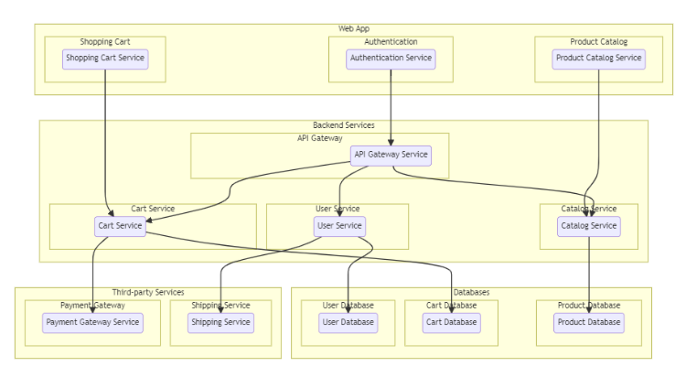The technical architecture of an flower and gift delivery app typically involves a client-server model, where the frontend represents the client and the backend serves as the server. The frontend is responsible for user interface, interaction, and presentation, while the backend handles data storage, business logic, and integration with external services like payment gateways and databases. Communication between the frontend and backend is typically facilitated through APIs, enabling seamless data exchange and functionality.

**APPLICATION FLOW**

1. **USER FLOW:**

* View products: Users can search for products, based on interest.
* Product bookings: Users can select products that are available and complete the order process.
* Manage product booking: Users can view their own product order bookings, modify booking details, track booking details, and cancel their bookings
* Manage cart: Users can view their cart details and modify them if needed.

1. **ADMIN FLOW:**

* Manage: Admins can add, edit, and delete shop information along with products.
* Manage product bookings: Admins can view and manage all product bookings made by users and agents, including cancelling or modifying product bookings.
* Manage users: Admins can create, edit, and delete user accounts, as well as manage their roles and permissions

**FEATURES AND FUNCTIONALITIES:**

A **grocery web app** is designed to simplify online grocery shopping. Below are its key **features and functionalities**:

**1. User Account Management**

* **Sign-up/Login**: Allows users to create accounts and log in.
* **Profile Management**: Users can update personal details, delivery addresses, and preferences.

**2. Product Catalogue**

* **Categorized Products**: Products organized into categories (fruits, vegetables, dairy, etc.).
* **Search and Filter**: Easy search with filters (price, brand, popularity, etc.).
* **Detailed Product Info**: Descriptions, prices, nutritional values, and reviews.

**3. Cart and Checkout**

* **Add to Cart**: Add or remove items from the shopping cart.
* **Save for Later**: Save items for future purchases.
* **Checkout Process**: Secure checkout with multiple payment options (cards, wallets, cash on delivery).

**4. Payment Integration**

* **Multiple Payment Methods**: Credit/debit cards, UPI, net banking, and wallets.
* **Order Summary**: Detailed cost breakdown before payment.
* **Discounts and Coupons**: Apply promo codes or loyalty points.

**5. Order Management**

* **Track Orders**: Real-time order status updates.
* **Order History**: View past orders for reordering.
* **Scheduled Delivery**: Choose preferred delivery date and time.

**6. Notifications and Alerts**

* **Stock Alerts**: Notify when an item is back in stock.
* **Order Updates**: SMS/email/app notifications for order milestones.
* **Offers and Promotions**: Inform users about discounts and deals.

**7. Wishlist**

* Save favorite items for quick access later.

**8. Customer Support**

* **Chat/Call Support**: Direct help for queries.
* **FAQ Section**: Common issues and solutions.

**9. Admin Panel**

* Manage inventory, pricing, and user data.
* Monitor sales and generate reports.

**10. Mobile Responsiveness**

* Optimized for desktops, tablets, and smartphones.

**11. Additional Functionalities**

* **Subscription Plans**: Regular delivery of staple items.
* **Multi-Language Support**: Accessibility for diverse users.
* **AI-based Recommendations**: Suggest products based on purchase history.

**DATABASE DESIGN:**

**ER-MODEL**

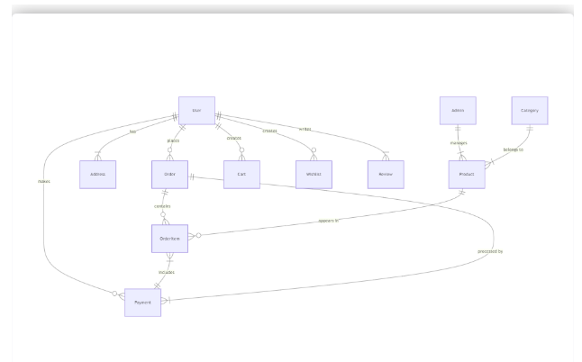The Entity-Relationship (ER) diagram for an flower and gift delivery app visually represents the relationships between different entities involved in the system, such as users, products, orders, and reviews. It illustrates how these entities are related to each other and helps in understanding the overall database structure and data flow within the application.

• **User**

* **Attributes**: User_ID (Primary Key), Name, Email, Password, Address, Phone_Number.
* Represents the customers using the web app.

• **Product**

* **Attributes**: Product_ID (Primary Key), Name, Category, Price, Stock_Quantity, Description.
* Represents the grocery items available for purchase.

• **Cart**

* **Attributes**: Cart_ID (Primary Key), User_ID (Foreign Key), Total_Amount.
* Represents the shopping cart for each user.

• **Cart_Item**

* **Attributes**: Cart_Item_ID (Primary Key), Cart_ID (Foreign Key), Product_ID (Foreign Key), Quantity.
* Links specific products to a user's cart.

• **Order**

* **Attributes**: Order_ID (Primary Key), User_ID (Foreign Key), Order_Date, Delivery_Date, Total_Amount, Payment_Status.
* Represents orders placed by users.

• **Order_Item**

* **Attributes**: Order_Item_ID (Primary Key), Order_ID (Foreign Key), Product_ID (Foreign Key), Quantity, Subtotal.
* Tracks individual items within an order.

• **Payment**

* **Attributes**: Payment_ID (Primary Key), Order_ID (Foreign Key), Payment_Method, Payment_Date, Payment_Status.
* Represents the payment details for an order.

• **Category**

* **Attributes**: Category_ID (Primary Key), Name, Description.
* Represents product categories (e.g., Fruits, Vegetables, Dairy).

• **Admin**

* **Attributes**: Admin_ID (Primary Key), Name, Email, Password.
* Represents administrators managing the app.

**IMPLEMENTATION:**

The implementation of a **grocery web app** involves several key steps, focusing on both the front-end (user interface) and back-end (server-side functionality).

* Front end Development
* Back end Development
* Database Design
* Integration
* Testing and Deployment
* Maintenance and Updates

**PROJECT SETUP AND CONFIGURATION**

1. **Install required tools and software**:

* Node.js
* Angular CLI
* MongoDB

1. **Create project folders and files**:

* Client folders
* Server folders

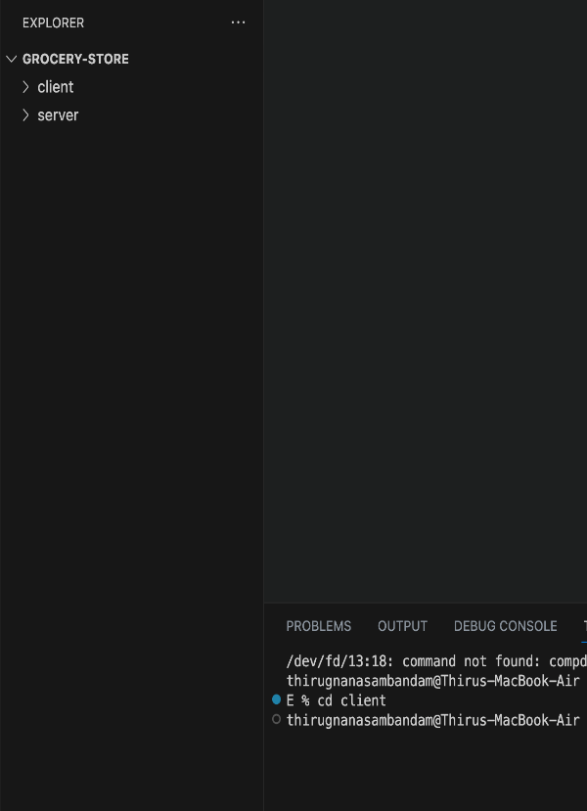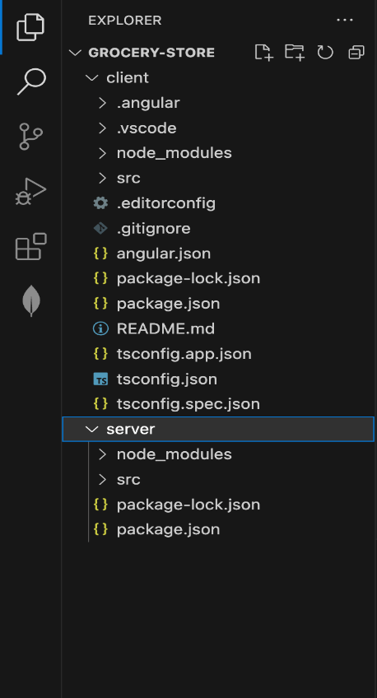

**BACKEND DEVELOPMENT**

**Set Up Project Structure:**

* Create a new directory for your project and set up a package.json file using npm init command.
* Install necessary dependencies such as Express.js, Mongoose, and other required packages.

**Database Configuration:**

* Set up a MongoDB database either locally or using a cloud-based MongoDB service like MongoDB Atlas.
* Create a database and define the necessary collections for hotels, users, bookings, and other relevant data.

**Create Express.js Server:**

* Set up an Express.js server to handle HTTP requests and serve API endpoints.
* Configure middleware such as body-parser for parsing request bodies and cors for handling cross-origin requests.

**Define API Routes:**

* Create separate route files for different API functionalities such as hotels, users, bookings, and authentication.
* Define the necessary routes for listing hotels, handling user registration and login, managing bookings, etc.
* Implement route handlers using Express.js to handle requests and interact with the database.

**Implement Data Models:**

* Define Mongoose schemas for the different data entities like hotels, users, and bookings.
* Create corresponding Mongoose models to interact with the MongoDB database.
* Implement CRUD operations (Create, Read, Update, Delete) for each model to perform database operations.

**User Management and Authentication:**

* Implement user registration and login functionality.
* Choose an authentication mechanism like session-based authentication or token-based authentication (e.g., JWT).
* Store and hash user credentials securely.
* Implement middleware to authenticate API requests and authorize access to protected routes.

**Product Catalog and Inventory Management:**

* Design the database schema to store product details, pricing, availability, and inventory levels.
* Create APIs to retrieve product information, update inventory quantities, and handle search and filtering.
* Implement validations to ensure data integrity and consistency.

**Shopping Cart and Order Management:**

* Design the database schema to store shopping cart details and order information.
* Create APIs to handle cart operations like adding items, modifying quantities, and placing orders.
* Implement logic to calculate totals, apply discounts, and manage the order lifecycle.

**Payment Gateway Integration:**

* Choose a suitable payment gateway provider (e.g., Stripe, COD).
* Integrate the payment gateway SDK or API to handle secure payment processing.
* Implement APIs or callback endpoints to initiate transactions, handle payment callbacks, and receive payment confirmation.

**Shipping and Logistics Integration:**

* Identify shipping and logistics providers that align with your application's requirements.
* Utilize the APIs provided by these providers to calculate shipping costs, generate shipping labels, and track shipments.
* Implement APIs or services to fetch rates, generate labels, and obtain tracking information.

**Database Integration:**

* Choose a suitable database technology (e.g., MySQL, PostgreSQL, MongoDB) based on your application's requirements.
* Design the database schema to efficiently store and retrieve flower and gift delivery data.
* Establish a connection to the database and handle data persistence and retrieval.

**External Service Integration:**

* Identify third-party services like email service providers, analytics services, or CRM systems that are required for your application.
* Utilize the APIs or SDKs provided by these services to exchange data and perform necessary operations.
* Implement the integration logic to send order confirmations, track user behavior, or manage customer relationships.

**Security and Data Protection:**

* Apply appropriate security measures like encryption techniques for secure data transmission and storage.
* Implement input validation and sanitization to prevent common security vulnerabilities.
* Implement access control to ensure authorized access to sensitive data.

**Error Handling and Logging:**

* Implement error handling mechanisms to handle exceptions and provide meaningful error messages to the frontend.
* Use logging frameworks to record application logs for monitoring and troubleshooting purposes.

**FRONTEND DEVELOPMENT**

### User Interface (UI) Design:

* Create a visually appealing and consistent design using modern design principles.
* Use a UI design tool like Adobe XD, Sketch, Figma, or InVision to create wireframes and mockups.
* Pay attention to typography, color schemes, spacing, and visual hierarchy.
* Use responsive design techniques to ensure the app looks great on different devices.

### Responsive Design:

* Utilize CSS media queries and responsive design frameworks like Bootstrap or Tailwind CSS to create a responsive layout.
* Test your app on various devices and screen sizes to ensure a seamless user experience.

### Product Catalog:

* Design and implement a product listing page that displays product images, titles, descriptions, prices, and other relevant details.
* Implement search functionality to allow users to find products easily.
* Include filters and sorting options to enhance the browsing experience.

### Shopping Cart and Checkout Process:

* Design and develop a shopping cart component to allow users to add products, view cart contents, update quantities, and remove items.
* Create a checkout process with multiple steps, including shipping information, payment selection, and order review.

### User Authentication and Account Management

* Design and implement a user registration and login system.
* Create user profile pages where users can view and edit their personal information, addresses, payment methods, and order history.
* Implement authentication guards to restrict access to certain pages or features.

### Payment Integration

* Integrate with a payment gateway service like Stripe, PayPal, or Braintree.
* Implement a secure and seamless payment flow that allows users to enter payment details and complete transactions.
* Handle transaction success and failure scenarios and provide appropriate feedback to the user.

**SCHEMA USE-CASE**:

1. **User Schema**:

• Schema: userSchema

• Model: ‘User’

• The User schema represents the user data and includes fields such as username, email, and password.

• It is used to store user information for registration and authentication purposes.

• The email field is marked as unique to ensure that each user has a unique email address

1. **Product Schema**:

• Schema: productSchema

• Model: ‘Product’

• The Product schema represents the data of all the products in the platform.

• It is used to store information about the product details, which will later be useful for ordering

1. **Orders Schema**:

• Schema: ordersSchema

• Model: ‘Orders’

• The Orders schema represents the orders data and includes fields such as userId, product Id, product name, quantity, size, order date, etc.,

• It is used to store information about the orders made by users.

• The user Id field is a reference to the user who made the order.

1. **Cart Schema**:

• Schema: cartSchema

• Model: ‘Cart’

• The Cart schema represents the cart data and includes fields such as userId, product Id, product name, quantity, size, order date, etc.,

• It is used to store information about the products added to the cart by users.

• The user Id field is a reference to the user who has the product in cart.

5. **Admin Schema**:

• Schema: adminSchema

• Model: ‘Admin’

• The admin schema has essential data such as categories, banner.

**TESTING AND DEPLOYMENT**

## **Testing**

Testing is a crucial phase in the development of any application to ensure that all functionalities are working as expected and to prevent any potential issues from reaching end-users.

**Unit Testing**

Unit testing focused on verifying that individual components of the application functioned correctly in isolation. The backend APIs were tested using **Postman** to ensure proper request handling, response structure, and data formatting.

* + - **API Endpoint Testing**: Each API endpoint, such as user registration, login, product fetching, and order placement, was tested with various inputs to ensure it handled both valid and invalid requests properly.
    - **Edge Case Testing**: A significant focus was placed on edge cases like invalid user input (e.g., incorrect email format, missing fields), authentication failures (wrong password), and unauthorized access (restricted routes). The responses for these cases were verified to ensure proper error handling and user feedback (e.g., 400 or 401 errors for bad requests or unauthorized access).
    - **Security Testing**: Sensitive endpoints, such as authentication routes, were specifically tested for potential vulnerabilities, ensuring no security breaches (e.g., improper password handling, exposure of JWT secrets).

### Integration Testing

Integration testing was performed to ensure the frontend and backend communicated properly and that the system as a whole worked correctly. This involved testing full user workflows, including interactions between the client-side and server-side components.

* + - **End-to-End Workflows**: User flows like registration, login, adding products to the cart, proceeding to checkout, and placing orders were simulated. These workflows tested whether data was correctly passed between the frontend and backend, ensuring that users could seamlessly interact with the platform.
    - **API Interaction**: The frontend, built in React, used **Axios** to communicate with the backend APIs. All API requests, such as fetching product lists, updating the cart, and placing orders, were tested to confirm that the data from the backend was correctly rendered on the frontend, and vice versa.

### Database Testing

The database layer was rigorously tested to ensure data integrity and the efficient handling of user, product, and order information.

* + - **Query Testing**: MongoDB queries were tested to ensure proper insertion, retrieval, and updating of documents in collections. This included creating test users, adding products, and placing test orders.
    - **Relationships Between Collections**: The relationships between collections, such as products linked to sellers and orders linked to customers, were validated. Data consistency was confirmed by checking the linkage between products and orders, ensuring no orphaned or inconsistent data.
    - **Validation Testing**: Fields such as email and password were subjected to validation tests to confirm that rules were properly applied (e.g., password length, valid email formats).

### Performance Testing

Performance testing was essential to evaluate the efficiency and speed of the application under different levels of traffic.

* + - **Backend Performance**: Tools like **Apache JMeter** were used to simulate high traffic loads and test how the server handled multiple simultaneous requests. This helped identify bottlenecks or slow API endpoints that needed optimization.
    - **Database Performance**: Query optimization was another key focus. Slow queries were identified and optimized by indexing frequently searched fields (e.g., product name, category). The database was also tested for scalability to ensure it could handle increased traffic.

## **Deployment**

Once the testing phase was complete, the next step was to prepare the platform for production deployment. The deployment process was carried out in stages, starting with setting up the hosting environment, optimizing the application, and then going live. Here’s a detailed breakdown of the deployment process:

### Frontend Deployment

### Optimizing React for Production: The React application was optimized using the npm run build command, which generated static files (HTML, CSS, and JavaScript) ready for deployment. These static files were minified and bundled to improve loading times and performance.

### Hosting the Frontend: The optimized files were deployed to Vercel and Netlify, both of which provide services for hosting static websites with automatic builds, SSL encryption, and easy custom domain integration.

### Domain Configuration: A custom domain was set up to host the frontend, providing a professional and memorable URL for users to access the platform.

**Backend Deployment**

The backend, built using **Express.js** and **Node.js**, was deployed to a cloud server to ensure scalability and high availability.

* **Choosing a Cloud Platform**: The backend was deployed to **Heroku** or **AWS**. Heroku was chosen for its simplicity and integration with Git, while AWS offered more flexibility for scaling as the user base grew.
* **Environment Configuration**: Sensitive environment variables, such as MongoDB connection strings and JWT secrets, were securely configured using **Heroku Config Vars** or **AWS Environment Variables**.
* **Database Integration**: The backend was connected to **MongoDB Atlas**, a cloud- hosted MongoDB service that provides scalability and reliability. MongoDB Atlas was chosen for its managed hosting, automatic backups, and performance monitoring features.

### Analytics and Feedback

Once live, the platform was continuously improved based on user feedback and real-time analytics.

* **Google** **Analytics**: The platform integrated Google Analytics to monitor user traffic, including metrics such as page views, session duration, bounce rate, and geographical location. This data provided valuable insights into user behavior and engagement.
* **User Feedback**: A feedback mechanism was implemented to gather user suggestions for further enhancements, ensuring that the platform remained user-centered and continuously evolved based on customer needs

By executing a structured and thorough testing process followed by a reliable deployment strategy, Grocery Webapp was launched as a fully functional, secure, and user-friendly e-commerce platform. The combination of robust testing, careful monitoring, and continuous feedback helped create a stable and scalable solution for both customers and sellers.

**Output Screenshots**

*Fig.1: Welcome Page*

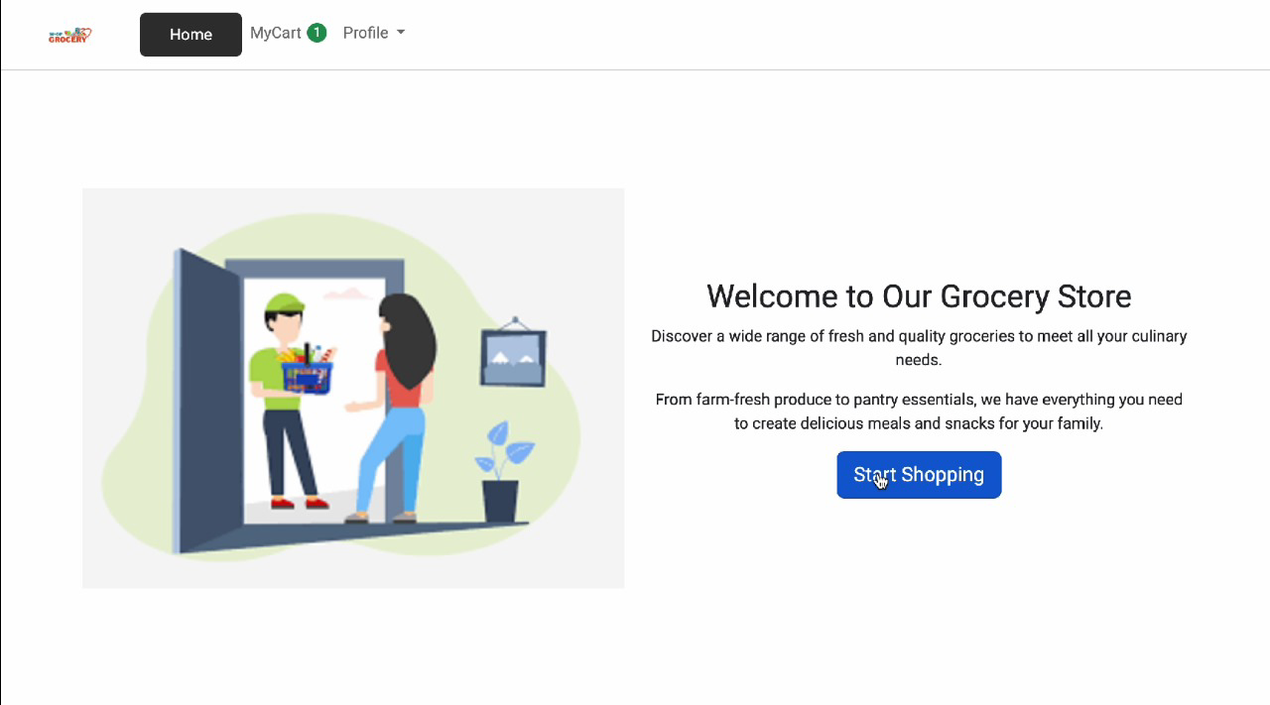

*Fig.2: Login page*

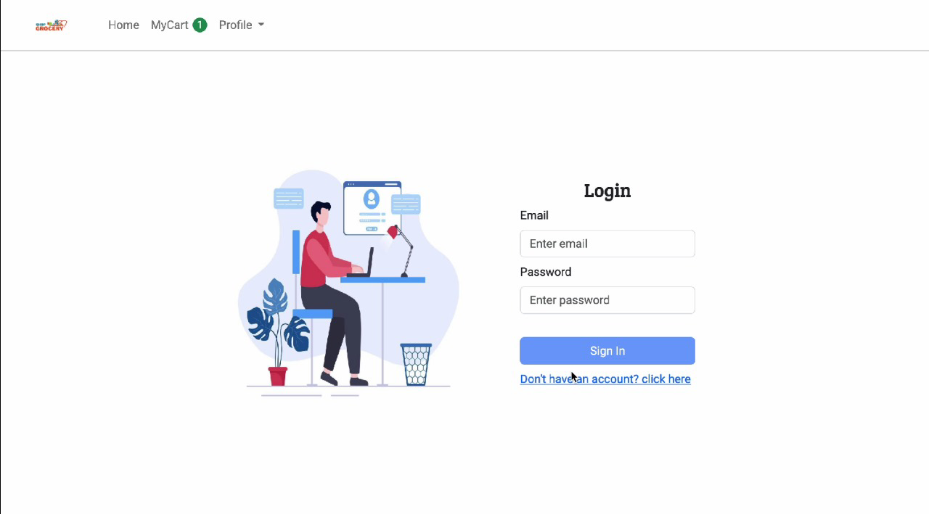

*Fig.3: Home page*

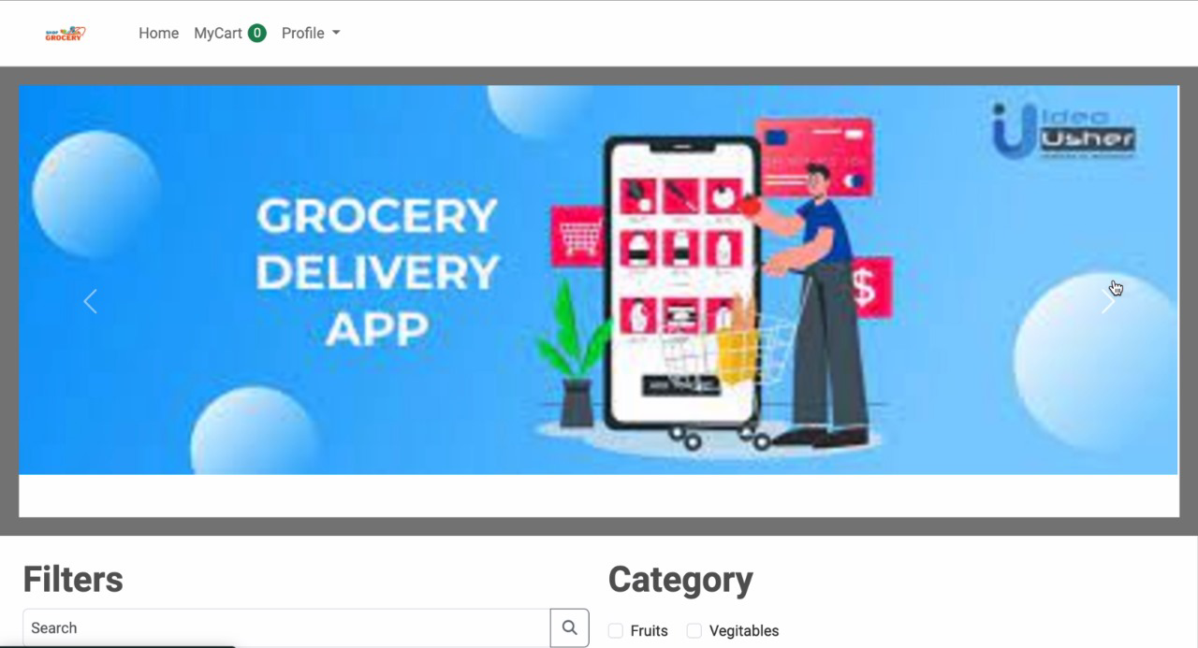

*Fig.4: Product*

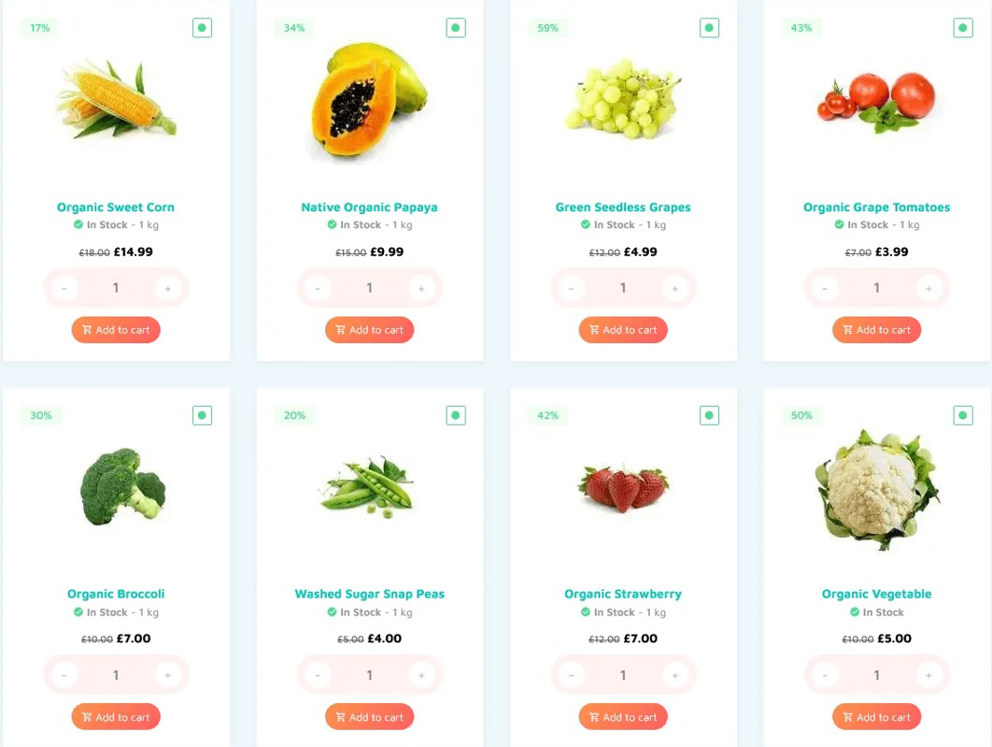

*Fig.5: Order Details*

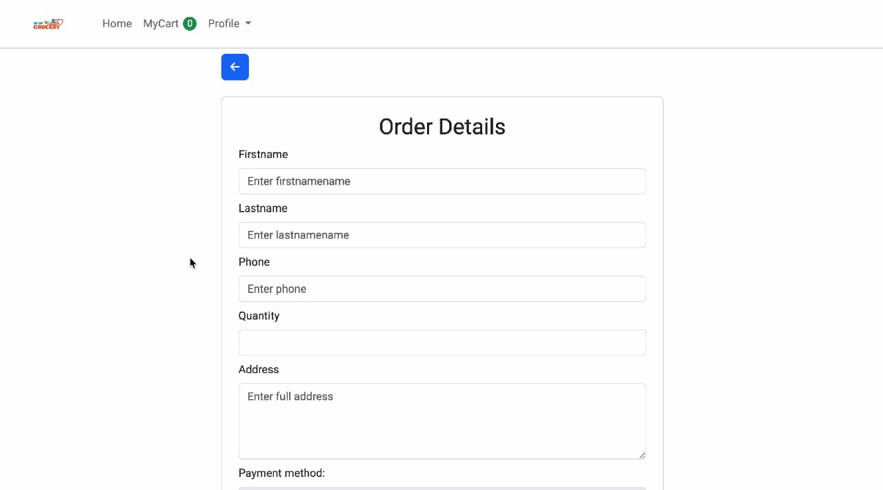

*Fig.6: Cart*

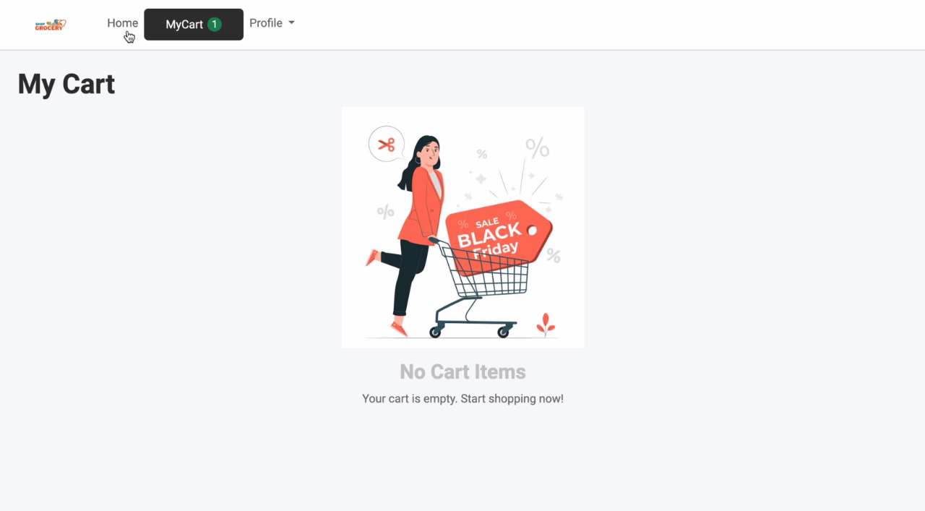

**CHALLENGES AND SOLUTIONS**  
Developing and deploying the grocery e-commerce platform presented unique challenges. Below are some of the key challenges encountered and the solutions implemented to address them:

1. **Handling User Authentication and Role Management**  
   Ensuring secure authentication and authorization for roles like customers, vendors, and admins was a priority, given the varying levels of access needed across the platform.
   * **Solution:**  
     Passwords were securely hashed using **bcrypt.js**, and **jsonwebtoken (JWT)** was employed for token-based authentication. Role-based access control was implemented to ensure customers, vendors, and admins could only access resources relevant to their roles. For instance, customers could view and manage orders, while vendors could update inventory and pricing.
2. **Maintaining Real-Time Inventory Data**  
   Real-time stock management was critical to ensure customers see accurate product availability and avoid issues like ordering out-of-stock items.
   * **Solution:**  
     **Mongoose** was used to maintain relationships between collections (Products, Orders, and Users). Middleware functions were added to automatically update product stock levels when orders were placed or canceled. A real-time event system using **Socket.IO** was introduced to notify vendors and customers of stock changes instantly.
3. **Optimizing Performance for High Traffic**  
   Handling large product catalogs and multiple simultaneous users required efficient data retrieval and minimal load times.
   * **Solution:**  
     Indexing was applied to fields frequently used in searches, such as product categories, names, and prices. A caching system (e.g., **Redis**) was implemented to store frequently queried data, reducing database calls and improving response times during peak usage.
4. **Ensuring a User-Friendly, Responsive Design**  
   Grocery shopping involves varied user behaviors, including quick searches and detailed filtering on mobile devices. Ensuring compatibility across devices was essential.
   * **Solution:**  
     The frontend was built using **React** and responsive components from **Material-UI**. A mobile-first approach ensured the design worked seamlessly on smartphones and tablets. User testing helped refine the interface for intuitive navigation and checkout processes.
5. **Addressing Payment and Data Security**  
   Handling sensitive user data, including payment details and addresses, required stringent security measures.
   * **Solution:**  
     Secure payment processing was implemented using **Stripe** and **PayPal** integrations. Libraries like **helmet** and **cors** were used to enhance HTTP header security and manage cross-origin requests. Additionally, all user passwords were hashed using **bcrypt.js** to prevent plaintext storage.

**FUTURE ENHANCEMENTS**  
While **FreshMart** is already functional, several features can be introduced to further enhance user experience and platform efficiency:

1. **Personalized Product Recommendations**  
   Using browsing and purchasing history to suggest products can streamline shopping. For example, recommending weekly essentials based on previous orders.
2. **Real-Time Delivery Tracking**  
   Adding live delivery tracking via integrations with logistics APIs would keep customers informed about their order status and estimated delivery time.
3. **Multi-Location Support**  
   Expanding the platform to allow regional variations in product availability and pricing. Vendors could manage stock and deliveries based on their specific locations.
4. **Mobile Application Development**  
   Building native mobile apps for Android and iOS with features like push notifications for promotions or delivery updates would make the platform more accessible.
5. **AI-Powered Assistance**  
   Introducing an AI-driven virtual assistant to help customers quickly find products, answer common queries, or navigate the app.
6. **Vendor Analytics Dashboard**  
   Providing vendors with detailed analytics, such as:
   * Top-selling products.
   * Seasonal trends.
   * Stock alerts and suggestions for reorder quantities.

**CONCLUSION**

The **FreshMart** platform offers a streamlined and secure online grocery shopping experience, integrating efficient inventory management and a robust backend. From secure payments to responsive design, it ensures both usability and performance. Future enhancements like real-time tracking, personalized recommendations, and mobile apps can elevate the platform, ensuring it remains competitive in the growing online grocery market.

By continuously innovating and improving, **FreshMart** can become a trusted choice for customers and vendors alike, setting a standard in the online grocery space.

**REFERENCES**

1. [MERN Stack Documentation](https://www.mongodb.com/mern-stack)
2. [JWT Authentication in Node.js](https://jwt.io/introduction/)
3. [Mongoose Documentation](https://mongoosejs.com/docs/)
4. [React Documentation](https://reactjs.org/docs/getting-started.html)
5. [Stripe API Documentation](https://stripe.com/docs/api)